—— Introduction to Health Products ————————————————

Respiratory and Heartbeat Monitoring Radar

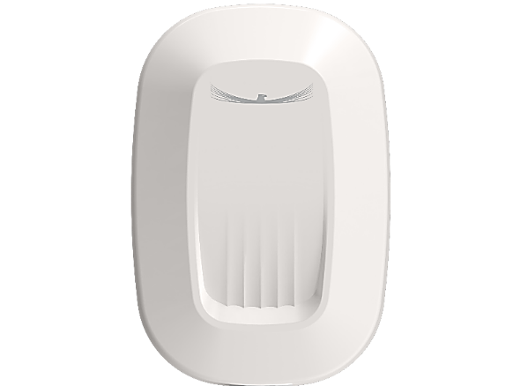

**Product Introduction**
The Respiratory and Heartbeat Monitoring Radar is a millimeter-wave radar system designed to monitor the breathing and heartbeat rates of individuals during sleep. It enables real-time tracking of respiratory and cardiac data, detects personnel departure, and continuously assesses physical status and in-bed presence. In the event of abnormal vital sign readings, the system automatically sends alert notifications to family members or healthcare institutions via WeChat mini programs, facilitating prompt follow-up and intervention.

**Product Characteristics**
- High-performance FMCW modulation technology with a highly integrated MMIC architecture
- Phased array radar utilizing DBF (Digital Beamforming) technology
- Equipped with 4 transmitting and 4 receiving antennas
- Detection range adjustable between 0.2 and 2 meters
- Ultra-wide detection coverage of up to 100°
- Ensures user privacy through non-invasive monitoring
- Rapid system initialization

**Application Scene**
- Hospital wards
- Nursing homes and rehabilitation centers
- Home healthcare and wellness monitoring
- Home health and wellness
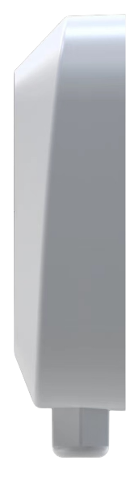
**Performance Parameter**
Parameter | Numerical Value
Radar Performance
Frequency Band | 60GHz
Bandwidth | 4GHz
Maximum Transmission Power | 21 dBm（EIRP）
Detection Range | 1 to 2metres
Horizontal Beamwidth | -50° to +50°
Pitch Beamwidth | -40° to +40°
General Parameters
Temperature | -40℃ to +70℃
Protection Level | IP67
Weight | 147 g
Power Supply | 9V to 12 V
Power Consumption | ≤2W
Dimensions (Length × Width × Height) | 104mm × 70mm × 34mm
Device Interface | RS-485/WIFI/Bluetooth

—— Introduction to Health Products ————————————————

Fall Detection Radar

**Product Introduction**
The Fall Detection Radar is a millimeter-wave radar system capable of detecting whether a target has fallen. It enables accurate perception of human body status for indoor personnel monitoring. In the event of a fall, the system automatically sends abnormal alarm notifications to family members or nursing institutions via WeChat mini programs, facilitating timely follow-up and response.

**Product Characteristics**
- High-performance FMCW modulation technology with a highly integrated MMIC architecture
-Phased array radar utilizing DBF (Digital Beamforming) technology
-Equipped with 4 transmitting and 4 receiving antennas
- Ultra-wide detection coverage of up to 100°
-Ensures user privacy through non-invasive monitoring
- Rapid system initialization

**Application Scene**
- Hospital wards
- Nursing homes and rehabilitation centers
- Home healthcare and wellness monitoring

**Performance Parameter**
Parameter | Numerical Value
Radar Performance
Frequency Band | 60GHz
Bandwidth | 4GHz
Maximum Transmission Power | 21 dBm（EIRP）
Detection Range | ≤19㎡（Installed at a height of 3 meters）
Horizontal Beamwidth | -50° to +50°
Pitch Beamwidth | -40° to +40°
General Parameters
Temperature | -40℃ to +70℃
Protection Level | IP67
Weight | 147g
Power Supply | 9V to 12 V
Power Consumption | ≤2W
Dimensions (Length × Width × Height) | 104mm × 70mm × 34mm
Device Interface | RS-485/WIFI/ Bluetooth

